**DIGITAL LOGIC DESIGN**

**PROJECT PROPOSAL**



|  |  |
| --- | --- |
| Group Members Name & Reg # | Muhammad Haris Irfan | Sana Elahi  **FA18-BCE-054**  **FA18-BCE-090** |
|  |  |
| Class | Digital Logic Design CPE241 (**BCE-2B**) |
| Instructor’s Name | Sir Muhammad Imran Saeed Lodhi |

**Line Following Robot**

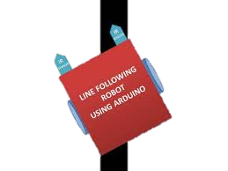

**What is a Line Following Robot?**

Line following robot can detect bright light using sensors and it defines its motion accordingly, after sensing the line it maneuvers to stay on course while correcting wrong moves, It will be a robot that will basically follow the path determined by the user, the path maybe as simple as a straight or a curved line or it may be as complex as a 90 degree turn.

The line follower robot built in this project is divided in to 4 blocks. The following image shows the block diagram for line follower robot.

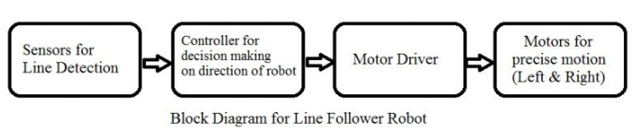

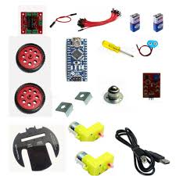**Components Required**

* 1 L293D motor driver IC.
* 1 4069 not gate IC
* 1 7805 5-volt regulator IC.
* 2 Pc Motor
* 3 Pc wheels
* one bread board/PCB
* Power Supplies 9V
* 1 Pc Robot Chassis
* Connecting Wires
* 2x Infrared Sensors

**High Level Diagram**

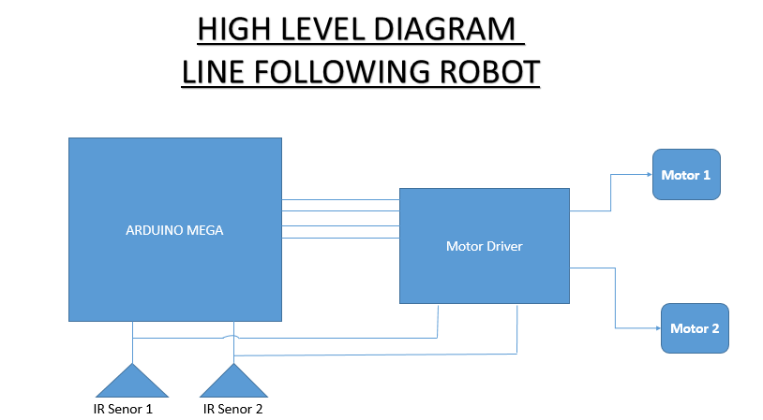

Motor Driver IC

Not Gate IC

Figure: 1

**Working Principle:**

In this project, we will develop Line Follower Robot. It will detect the black line on the surface and move along that line. The working has been explained in the succeeding paragraph.

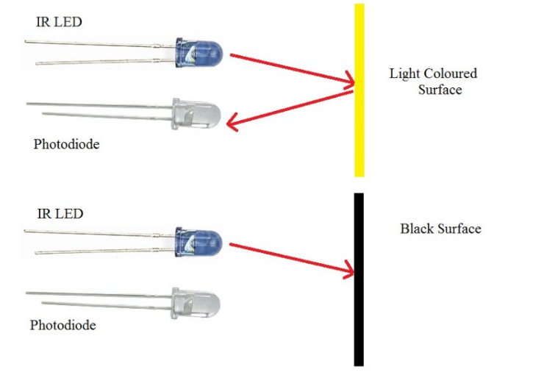 A Motor Driver IC L293D will be used along with a N for connecting motor and sensor for line detection and movement control. Two IR Sensors for right and left will be used in both receive/ transmit mode (IR LED and Photo Diode). Sensors will be placed in a reflective way i.e. side – by – side so that whenever they will come in to proximity of a reflective surface, the light emitted by IR LED will be detected by Photo diode.

**Figure 2** shows the working of a typical IR Sensor (IR LED – Photodiode pair) in front of a light-colored surface and a black surface. As the reflectance of the light-colored surface is high, the infrared light emitted by IR LED will be maximum reflected and will be detected by the Photodiode. In case of black surface, which has a low reflectance, the light gets completely absorbed by the black surface and doesn’t reach the photodiode.

Figure: 2

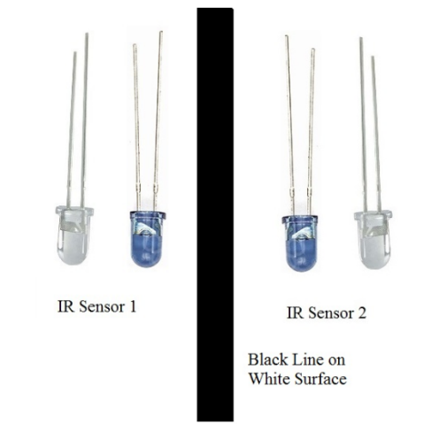Using the same principle, we will setup the IR Sensors on the Line Follower Robot such that the two IR Sensors are on the either side of the black line on the floor.

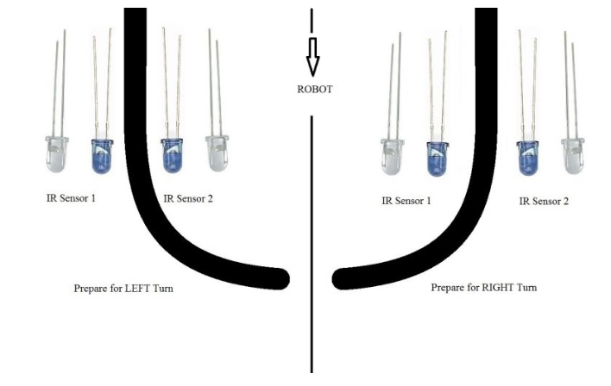When the robot moves forward, both the sensors wait for the line to be detected. For example, if the IR Sensor 1 in the above image detects the black line, it means that there is a right curve (or turn) ahead.

Figure: 3

Not Gate IC detects this change and sends signal to motor driver IC accordingly. In order to turn right, the motor on the right side of the robot is slowed down using PWM (Pulse Width Modulation), while the motor on the left side is run at normal speed.

Figure: 4

**Line following Robot- An advancement of technology!**

The line following Robot is basically an advanced automated mobile operator which is being successfully used in many industrial and public fields to aid the work burden as it requires no human operating and can perform repetitive tasks following its assigned trajectory path with supervision, thus making manual work easier for humans in this era of rapid, demanding and progressive lifestyle.

**Request:** We hope that our proposal is approved so that we can begin with the actual project as soon as possible.

*THANK YOU!*

**THE END**